**June feedback**

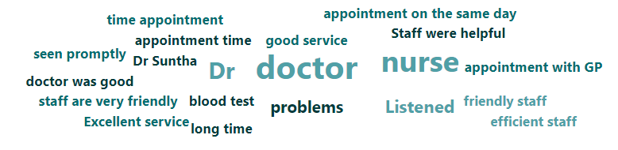

Feedback from Iplato –





Feedback from Accurex –

Excellent nurse made me feel at ease.

Felt ‘listened to’ by the doctor. Didn’t have to wait over time for my appointment. Treatment plan given.

Because it’s always been good for 86 years

Sandra the practice nurse is very good she made me feel that she is interested in my health and has a lovely manner. The best treatment I have had at the practice for a very long time.

The receptionists are always helpful and caring.

Rachel was great with me as I was very anxious about my appointment. She was very caring, calm and considerate which really helped my anxiety. She's very friendly and made me feel at ease. Wouldn't hesitate to come to see her again.

The problem I had was treated quickly & efficiently. I saw Dr Abdallah who was very kind, patient and explained exactly what had happened and the treatment needed. Cannot thank him enough.

Dr Suntha is exceptional GP.

Happy with treatment and pleasant staff.

Did ask my Gp in the morning and had a phone call confirming my appointment on the same day. Excellent service and the doctor were very helpful and quick to solve my problem.

The nurse was fantastic on both occasions. Very professional. Great treatment, advice, and friendly manner.

Clare was very professional in explaining the whole procedure.

Punctuality, thoroughness, knowledge and friendliness of staff and their general attitude!

Pam was brilliant as soon as she saw me, she said that I didn't look well after my inr checks she checked.my blood results from the hospital which confirmed I had a urine infection so she arranged for the doctor to see me after seeing the doctor she got a wheelchair to assist me back to my grandson car she couldn't have been more caring.

Doctor Alwis was friendly, very patient with me and understanding and showed genuine empathy. I have always had a great experience at Beech Hill relating to all services and I am very grateful for this.

Dr Brierley was very patient and thorough, and I felt very reassured after seeing her.

Receptionist (Lucy) was very helpful and went above and beyond to sort our prescription. dr Abdullah was brilliant with our daughter.

Rang the surgery at 9;30 saw an excellent lady doctor at 4: pm. First class service.

Other Feedback –

F + F feedback - practice has been brilliant and very supportive. doctor Misterek was wonderful. Thank you all very much.

patient brought a box of chocolates in for member of staff for helping her to set up ask my gp and System online.

F & F feedback - I can confirm when I deal with receptionist Taylor I get excellent service – he’s a star.

F & F feedback - excellent service they don't just try they do!

F & F feedback thanks to receptionist Dawn very helpful.

F & F feedback - thank you to receptionist Cheryl for sorting out my issue.

F & F feedback - thank you so much to receptionist Lucy, you really helped me to get my child an appointment I am so grateful.

phone call from patient to say receptionist Dawn has been brilliant and he knows we get a lot of negativity being doctors’ receptionist but wants to say thanks you as it really is appreciated.

Thank you, card, sent to doctor - my sincere thanks for your kindness and compassion sown at this very sad time.

Health care assistant Pam received a bunch of flowers saying thanks for listening and caring it means a lot.

Patient informed Health care assistant that Doctor Wilkinson who she saw was extremely thorough, efficient, and caring.

F & F feedback - 2 receptionist Lynn and Dawn are super stars thank you very much.

F & F feedback -very grateful for receptionist Cheryl for sorting out medication.