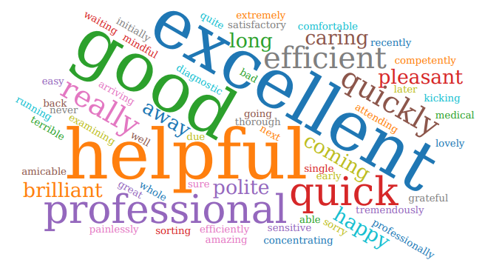

FEEDBACK FROM IPLATO

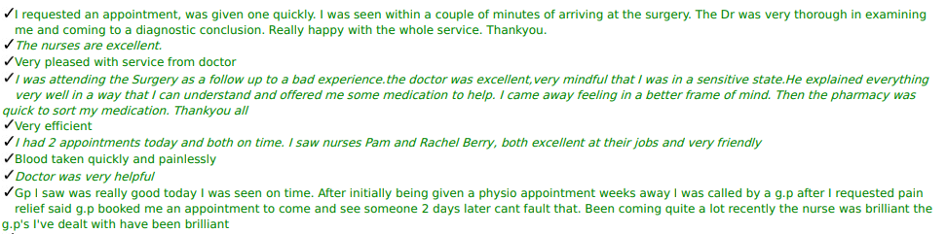

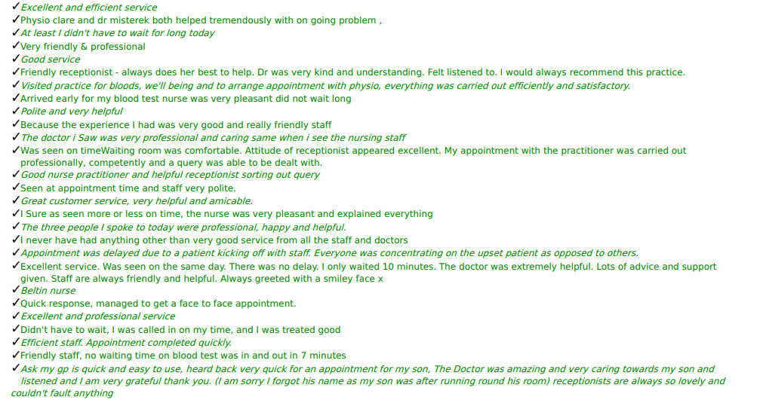

FEEDBACK FROM ACCUREX

Felt ‘listened to’ by the doctor. Didn’t have to wait over time for my appointment. Treatment plan given.

Sandra the practice nurse is very good she made me feel that she is interested in my health and has a lovely manner. The best treatment I have had at the practice for a very long time.

The receptionists are always helpful and caring.

Everything was explained to me what the probable cause was.

Rachel was great with me as I was very anxious about my appointment. She was very caring, calm and considerate which really helped my anxiety. She's very friendly and made me feel at ease. Wouldn't hesitate to come to see her again.

Mrs whittle was excellent for class.

Face to face with Dr Gupta was very good.

My experience was good, and I am always satisfied with treatment and response.

Doctor was very nice and friendly and put me at ease. She explained my problem very well.

Quick and easy Polite and knowledgeable staff

The problem I had was treated quickly & efficiently. I saw Dr Abdallah who was very kind, patient and explained exactly what had happened and the treatment needed. Cannot thank him enough.

Nathan excellent, wouldn't hesitate to recommend.

Both Dr Adnan and Rachel Berry (Practice Nurse) were very professional and helpful. My results were very quick too.

The reception staff are very helpful, and the medical staff are extremely supportive and listen to any concerns that you may have.

Pleasant friendly staff efficient service.

Very pleasant staff who show a real interest in your health.

The receptionist are all very friendly and the doctor, Healey that I saw was very supportive and considerate.

Doctor Alwis was friendly, very patient with me and understanding and showed genuine empathy. I have always had a great experience at Beech Hill relating to all services and I am very grateful for this.

Dr Suntha is professional he is so kind and warm and is a credit to you. He is always welcoming he goes above and beyond! Made me feel so at ease when I was worried about my little one! Thanks again.

Dr Brierley was very patient and thorough, and I felt very reassured after seeing her.

Caroline was exceptional, very professional, full explanations and a very smooth smear test completed.

Receptionist (Lucy) was very helpful and went above and beyond to sort our prescription. Dr Abdullah was brilliant with our daughter.

FEEDBACK OTHER

Thank you, letter - Cheryl thank for the sympathetic way you treated her husband when he came to an appointment with the doctor - you were so considerate, and I really appreciated your thoughtfulness.

Telephone call from patient to praise member of staff Dawn for help in sorting a prescription out - "Brilliantly helpful".

Email received to the practice - I have just come out of a face-to-face appointment with Doctor Gupta and I found her very compassionate and extremely helpful.

F & F feedback - thank you to reception - biscuits brought in as a thank you.

F & F feedback - thanks to the girls on reception, great team and very helpful. Helped me out when I was upset and anxious in the practice.

patient rang the practice to say that the service was outstanding, and he didn't feel rushed at all and ANP Diane was lovely.

Patient rang to say thank you as member of staff Dawn had been so helpful and thorough.

Patient rang to thank you to Dawn for taking the time to sort her husband prescription out and ringing her back to let her know even though she knows we are very busy.

Patients’ son rang the practice to say the ladies in the practice are always so king and helpful.

F & F feedback -had a text to leave feedback but unable to use mobile to do this - wanted to say excellent service, in and out quickly and reception staff are all wonderful.

F & F feedback - many thanks to reception staff Dawn and the doctor Brierley for sorting out an urgent appointment, excellent patient care and many thanks to all the staff.

Thank you, card - Just want to say thank you to the all the practice for all that you have done for me over the last few months. Named various members of staff to help with her recovery.

F & F feedback - the nurse who I saw Sandra put my mind at rest - she was brilliant and helpful.

Patient rang the practice to say that she had received a text to complete a survey after an appointment, but she does not use the internet but wanted to pass on her comments that she has no complaints with the practice.

F & F feedback - thank you to receptionist Cheryl for sorting out my same day appointment at Gp alliance much appreciated.

F & F feedback - receptionist Rebecca B was very helpful and booked my knee injection it was really kind.